For GSD customers being billed with power factor whose meter have been replaced with an AMI meter, the power factor will no longer be read. The power factor will be calculated using the KWH and KVARH index reads and stored in the installation fact PWERFACTOR.

For GSD customers being billed with the default power factor of 0.85 whose meter have been replaced with an AMI meter, the actual power factor will be calculated using the KWH and KVARH index reads and stored in the installation fact PWERFTCALC. They will still be billed the default power factor which is stored in installation fact PWERFACTOR.

From the SAP menu execute transaction ES32 to display the installation.
Enter the installation number and hit Enter.
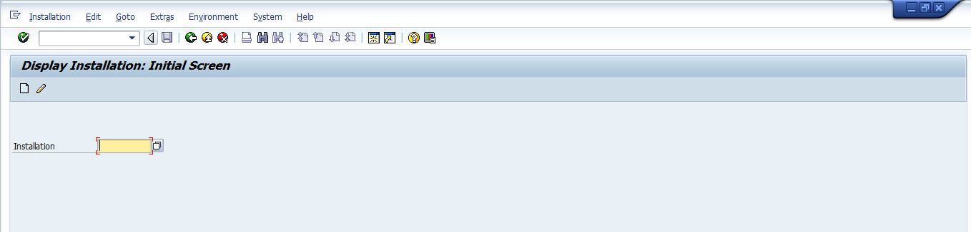

Click on the Facts button to display the installation facts
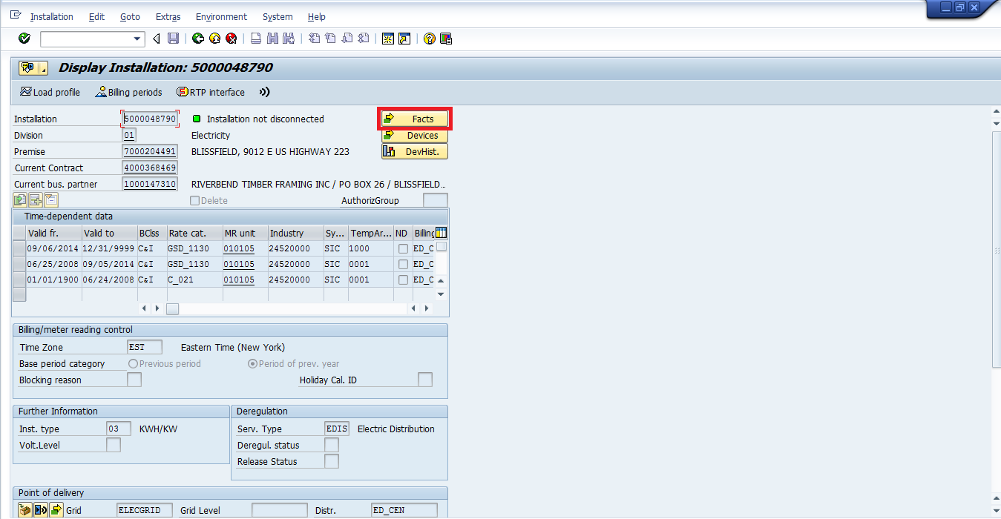

Expand the RUN TIME node
The power factor billed can be found in operand PWERFACTOR.
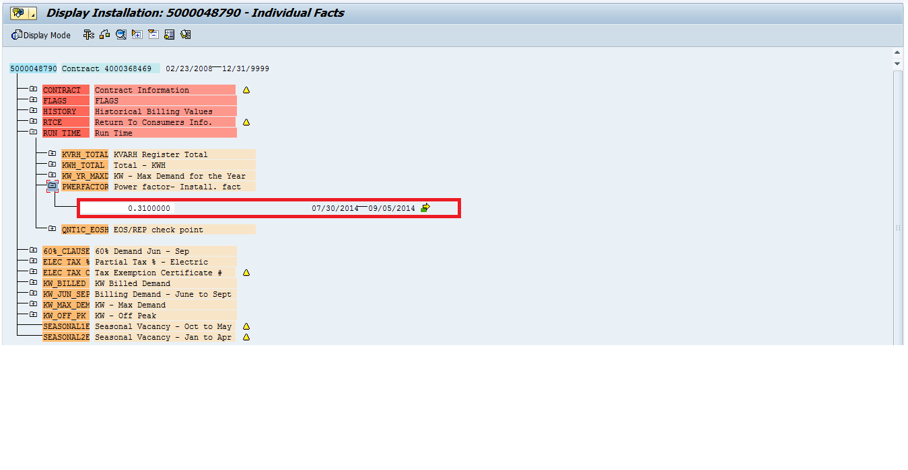

For customer being billed with the default power factor, the default power factor billed can be found in operand PWERFACTOR and the calculated power factor can be found in operand PWERFTCALC.
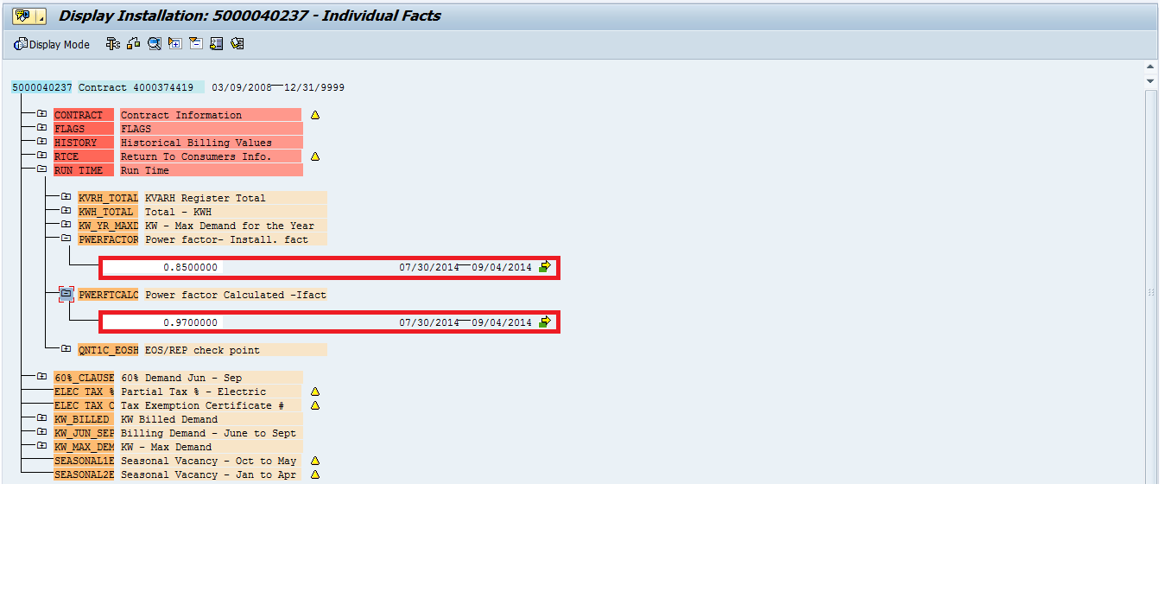

Revision History
Version | Author(s) | Date | Significant Changes
0.1 | Mary Jane Afable | 09/30/14 | Initial Document Release

